QUIZZ {1h00}

STUDENT FIRST NAME / LAST NAME: 

**WARNING**

**YOU NEED TO CHECK CAREFULLY STEP BY STEP THAT YOUR CODE WORKS**

**If you code does not work, you will get a 0 score**

**Exercise 1: (25 POINTS)**

|  |  |
| --- | --- |
| Objective | Pick up all diamonds |
| Maximum number of instructions | 10 |
| Allowed instructions | GO-UP GO-DOWN GO-LEFT GO-RIGHT PICK-UP  IF  REPEAT N-TIME WHILE |
| Allowed conditions | <HAS DIAMOND> |

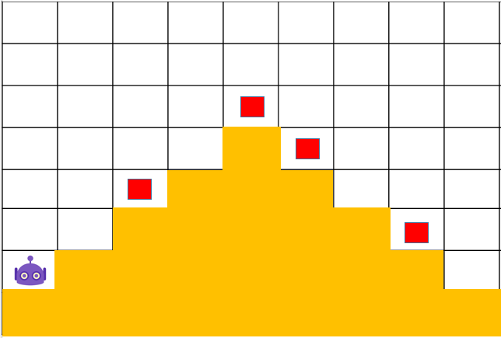

IF <HAS DIAMOND>

PICK UP

GO DOWN

GO RIGHT

REPEAT 3

REPEAT 4

PICK UP

IF <HAS DIAMOND>

GO RIGHT

GO UP

**Exercise 2: (25 POINTS)**

|  |  |
| --- | --- |
| Objective | Pick up all diamonds |
| Maximum number of instructions | 14 |
| Allowed instructions | GO-UP GO-DOWN GO-LEFT GO-RIGHT PICK-UP  IF  REPEAT N-TIME WHILE |
| Allowed conditions | <HAS DIAMOND> |

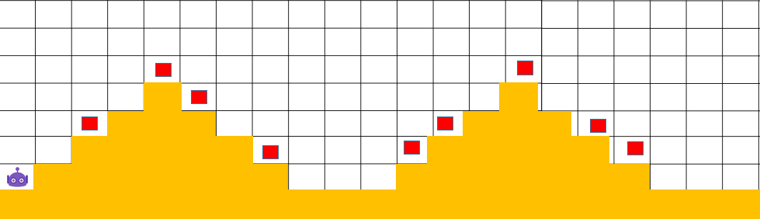

REPEAT 2

PICK UP

IF <HAS DIAMOND>

GO RIGHT

GO UP

REPEAT 4

**Exercise 3: (25 POINTS)**

GO RIGHT

GO RIGHT

REPEAT 4

GO RIGHT

GO DOWN

IF <HAS DIAMOND>

PICK UP

|  |  |
| --- | --- |
| Objective | Bring all carrots to their respective box |
| Maximum number of instructions | 13 |
| Allowed instructions | GO-UP GO-DOWN GO-LEFT GO-RIGHT PICK-UP DROP  IF  REPEAT N-TIME WHILE |
| Allowed conditions | <HAS CARROT> |

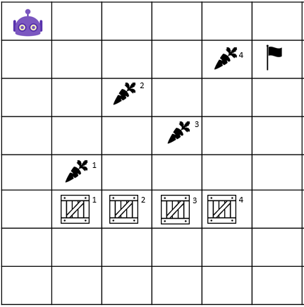

GO UP

REPEAT 5

DROP

GO DOWN

IF <HAS CARROT>

PICK UP

REPEAT 4

GO RIGHT

REPEAT 5

**Exercise 4: (25 POINTS)**

* Flag**:** ទង់ជាតិ

|  |  |
| --- | --- |
| Objective | Bring all carrot to their respective box **and** stop at the flag!!  WARNING : you program must work for the 2 cases !!! |
| Maximum number of instructions | 10 |
| Allowed instructions | GO-UP GO-DOWN GO-LEFT GO-RIGHT PICK-UP DROP  IF  REPEAT N-TIME WHILE |
| Allowed conditions | <HAS CARROT>  <HAS FLAG>  <HAS **NO** FLAG> |

CASE 1 CASE 2

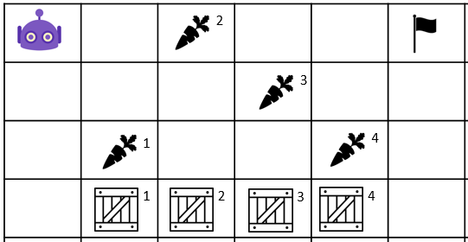 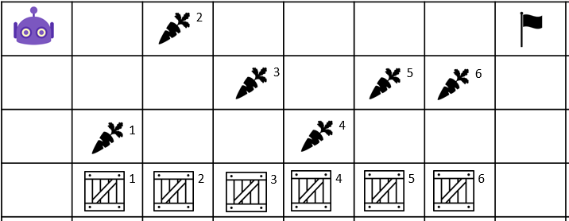

GO RIGHT

WHILE – HAS NO FLAG

DROP

REPEAT 3

GO UP

GO DOWN

PICK UP

IF – HAS CARROT

REPEAT 3